**Synopsis**

**ChatBot**

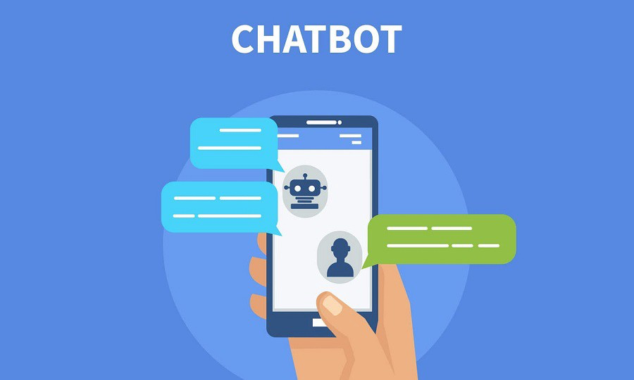

A **chatbot** is a smart application that reduces human work and helps an organisation to solve basic queries of the customer. Today most of the companies, business from different sectors make use of chatbots in a different way to reply to their customers as fast as possible. Chatbots also help in increasing traffic of sites which is the top reason for businesses to use chatbots.

Chatbot asks for basic information about customers like name, email address, and the query. If a query is simple like product fault, booking mistake, need some information then without any human connection it can solve it automatically and If some problem is high then It passes the details to the human head and helps customers to connect with organisation manager easily. And most of the customers like to deal and talk with a chatbot.

### **Why do we need Chatbots?**

* Cost and Time Effective ~ Humans cannot be active on-site 24/7 but chatbots can and the replying power of chatbots is much faster than humans.
* Cheap Development cost ~ with the advancement in technology many tools are developed that help easy development and integration of chatbots with little investment.
* Human Resource ~ Today Chatbots can also talk with text to speech technology so it gives the feel as a human is talking on another side.
* Business Branding ~ Businesses are changing with technology and chatbot is one out of them. Chatbot also helps in advertising, branding of organisation products and services and gives daily updates to users.

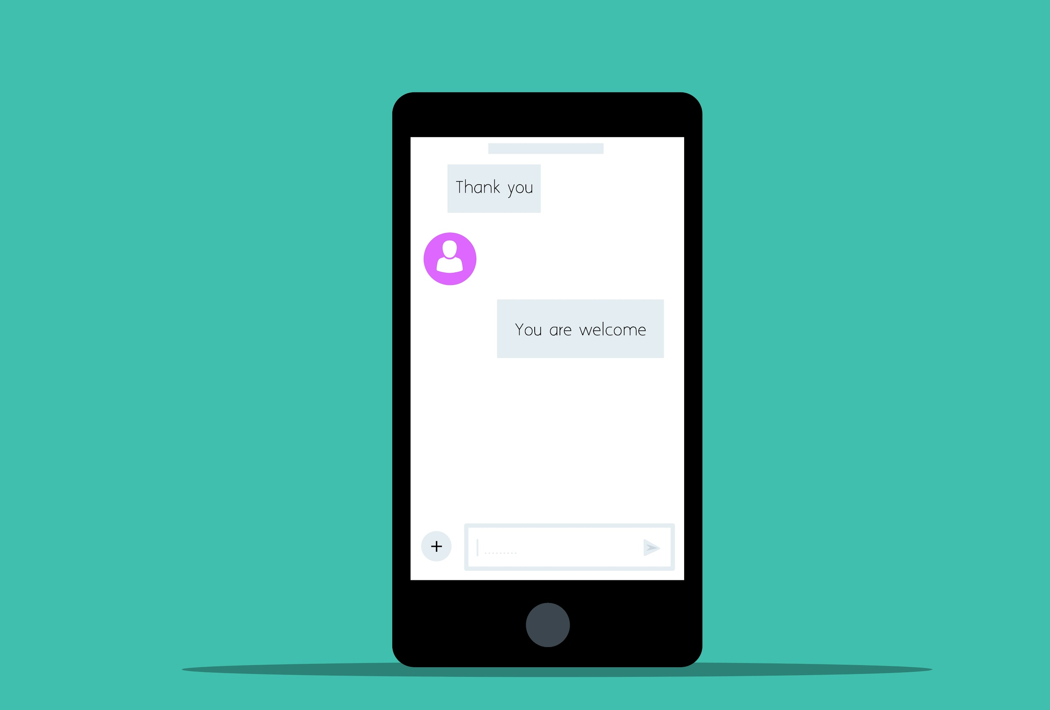

### **Types of Chatbots**

**There are mainly 2 types of chatbots.**

**1) Rule-based Chatbots** – As the Name suggests, there are certain rules on which chatbots operate. Like a Machine learning model, we train the chatbots on user intents and relevant responses, and based on these intents chatbot identifies the new user’s intent and response to him.

**2) Self-learning chatbots** – Self-learning bots are highly efficient because they are capable of grabbing and identifying the user’s intent on their own. They are built using advanced tools and techniques of Machine Learning, Deep Learning, and NLP. Self-learning bots are further divided into 2 subcategories.

* Retrieval-based chatbots:- Retrieval-based it is somewhat the same as Rule-based where predefined input patterns and responses are embedded.
* Generative-Based chatbots:- It is based on the same phenomenon as Machine Translation built using sequence 2 sequences neural network.

Most of the organization uses self-learning chatbot along with embedding some rules like Hybrid version of both methods which makes chatbot powerful to handle each situation during a conversation with a customer.

A **chatbot** is an artificial intelligence-powered piece of software in a device (Siri, Alexa, Google Assistant etc), application, website or other networks that try to gauge consumer’s needs and then assist them to perform a particular task like a commercial transaction, hotel booking, form submission etc .Today almost every company has a chatbot deployed to engage with the users. Some of the ways in which companies are using chatbots are:

* To deliver flight information
* to connect customers and their finances
* As customer support

**History of chatbots dates back to 1966 when a computer program called ELIZA was invented by Weizenbaum. It imitated the language of a psychotherapist from only 200 lines of code. You can still converse with it here:**

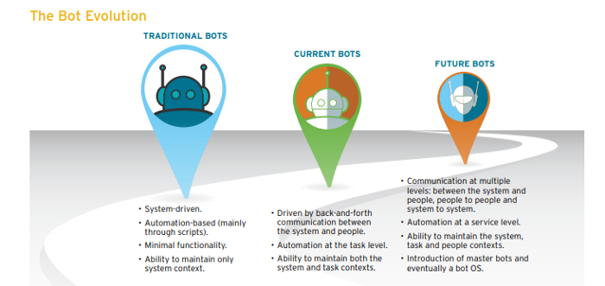

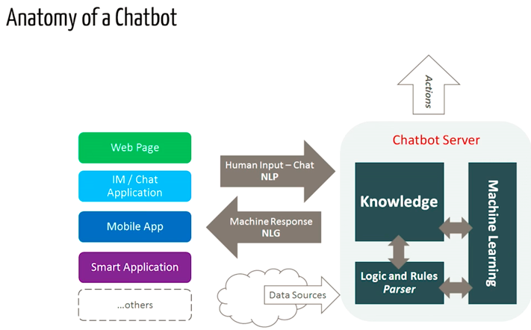

# **Building the Bot**

## Pre-requisites

A hands-on knowledge of **scikit** library and **NLTK** is assumed. However, if you are new to NLP, you can still read the article and then refer back to resources.

## **NLP**

The field of study that focuses on the interactions between human language and computers is called Natural Language Processing, or NLP for short. It sits at the intersection of computer science, artificial intelligence, and computational linguistics. NLP is a way for computers to analyze, understand, and derive meaning from human language in a smart and useful way. By utilising NLP, developers can organise and structure knowledge to perform tasks such as automatic summarization, translation, named entity recognition, relationship extraction, sentiment analysis, speech recognition, and topic segmentation.

## **NLTK: A Brief Intro**

NLTK (Natural Language Toolkit) is a leading platform for building Python programs to work with human language data. NLTK has been called “a wonderful tool for teaching and working in computational linguistics using Python,” and “an amazing library to play with natural language.”

**Natural Language Processing with Python** provides a practical introduction to programming for language processing.

**Downloading and installing NLTK**

1. Install NLTK: run pip install nltk
2. Test installation: run python then type import nltk

## **Installing NLTK Packages**

Import NLTK and run nltk.download().This will open the NLTK downloader from where you can choose the corpora and models to download. You can also download all packages at once.

## Text Pre- Processing with NLTK

The main issue with text data is that it is all in text format (strings). However, the Machine learning algorithms need some sort of numerical feature vector in order to perform the task. So before we start with any NLP project we need to pre-process it to make it ideal for working. Basic **text pre-processing** includes:

* Converting the entire text into **uppercase or lowercase**, so that the algorithm does not treat the same words in different cases as different
* **Tokenization**: Tokenization is just the term used to describe the process of converting the normal text strings into a list of tokens i.e words that we actually want. Sentence tokenizer can be used to find the list of sentences and Word tokenizer can be used to find the list of words in strings.